Heroku Garden Features

 | Instant Deployment When you create or import an app on Heroku, it's already live on the web. No configuration or tool setup necessary. |  | 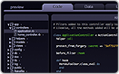 | Create and Edit Online Edit all of your code and data right in your browser. You can access it anywhere and there's nothing to install.
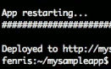 | Edit Locally, Deploy to Heroku Work locally like you always do. Then deploy your changes with a single command. |  |  | Import & Export Easily import or export your app's code, schema, and data at any time with just one click.
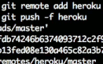 | Import with Git Use Git to push up a copy of your existing app, including all your revision history. |  |  | Share and Collaborate Make your app public to the web or private to users you specify. Add collaborators who can edit the app with you.
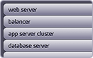 | Integrated Stack Heroku provides a full stack platform. No decisions necessary, just get straight to coding your app. |  |  | Elastic Performance Heroku is built on Amazon's Elastic Compute Cloud (EC2), so your apps have access to unlimited computing power.
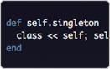 | Full Ruby Environment With a full Ruby and Rails runtime environment, you can run any Ruby code you can write, no limits. |  |  | Gems & Plugins Install any gem or plugin directly into your app with one click. Pull from the standard gem and plugin directories, or upload your own.
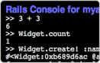 | Rails Console Execute code and manipulate data through a full Rails console running in a browser window. |  | 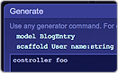 | Generate Code Use Rails generators to create code for your application. Run any generate command right in your browser.
 | Painless Migrations Unapplied migrations are automatically detected. Apply them with one click. |  | 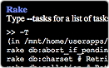 | Rake Tasks Run any rake command right from your browser.
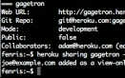 | Command-Line Collaboration Control sharing settings and invite new developers. |  | 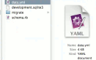 | Import a Database Use yaml_db to dump your app's database and upload it through a simple web form.

Sign up and give it a try.

